##### JAMIE 4.3 SMALL IN LAMBSKIN

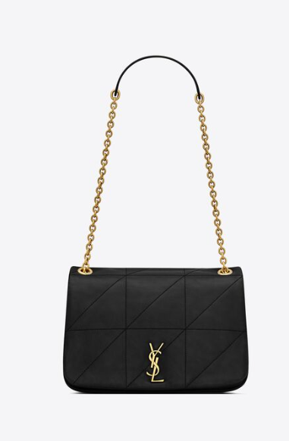  
The "Jamie 4.3 Small" bag is a popular design by the luxury fashion brand Saint Laurent. This bag is known for its sleek and minimalist silhouette, featuring clean lines and understated elegance. The "4.3" likely refers to its size, indicating that it's a compact or small-sized bag.

The use of lambskin leather in the construction of the Jamie 4.3 Small bag adds a luxurious touch, as lambskin is known for its softness and smooth texture. This material choice enhances the overall quality and feel of the bag.

Saint Laurent offers the Jamie 4.3 Small bag in various colors, hardware finishes, and sometimes with different embellishments or details. It typically features a chain strap that can be worn crossbody or doubled up for a shorter shoulder carry, providing versatility in styling.

If you're interested in purchasing the Jamie 4.3 Small in lambskin, you can explore Saint Laurent's official website or visit their boutique stores to see the latest offerings. Additionally, you can check with reputable luxury retailers or online platforms specializing in designer handbags to see if they have this specific bag available for purchase.